**iMagDent – Patient Management Web Application**

Proposal for the development of iMagDent web app

Sep 14th, 2020

Table of Contents

1.0 Company Information 1

2.0 Relevant Experience 2

3.0 Scope of work 5-11

4.0 Resources, Technologies, Pricing etc. 10-11

5.0 Maintenance & Support 12-13

1.0 Company Information

# 1.1 Company Name

Mitiz Technologies Pvt. Ltd.

# 1.2 Company Web Site

www.mitiztechnologies.com

# 1.3 Headquarters & Development Centers Address (City, State, Zip)

1) 24 7 Technologies LLC

1024 BERT MURPHY BLVD

BELLEVUE, NE 68005, USA

2) G-65, Sector 63

Noida, UP, India

3) 2297/2540, Om Tower,

Jaydev Vihar, Bhubaneswar,

Odisha, India

# 1.4 Is there a Parent Company? If yes, please specify name.

No, there is no any parent company of **Mitiz Technologies**. However, we have partnered with **24 7 Technologies LLC** having address 1024 BERT MURPHY BLVD BELLEVUE, NE 68005, in order to communicate with the clients based in United States of America.

# 1.5 If yes, how long has parent company owned this subsidiary?

N/A

# 1.6 Contact Name

Amrender Kumar

# 1.7 Contact Title

Managing Director

# 1.8 Contact Phone

+91-991-177-9839

# 1.9 Contact E-mail Address

amrender@mitiztechnologies.com

# 1.10 Number of years in business

Mitiz Technologies was founded in 2009 as Partnership firm and it was registered as Private Limited Company in 2014. In more than 10 subsequent years, our clients have trusted Mitiz Technologies and its predecessor organizations for solutions to their ever-changing needs. We are a national and global leader today because we have sustained our clients’ trust and exceeded their expectations throughout our history.

# 1.11 Publicly traded or privately held

Mitiz Technologies is a private limited company registered with Registrar of Companies in Odisha, India.

2.0 Relevant Experience

# 2.1 Statement about expertise in the Web Application and Mobile Application Development industry.

Mitiz Technologies is an ISO 9001:2015 certified company which has been launched with a crystal clear vision to provide multi-dimensional IT services across the sphere. We provide business standard web & mobile app development services to meet your business needs and to grow along with your organization. Our business mission is truly simple: build most exclusive, innovative & feature rich IT solutions for clients that yield results. We invest our best possible efforts on every single client’s need. Our professionals are always ready for facing new challenges in terms of stipulated time project delivery, quality anticipations of esteemed clients and measurable results. We are fully committed to deliver brilliant IT experiences while developing, designing, deploying, and managing online strategies for your organizations and in turn increasing your business ROI exponentially.

We have a history of serving more than 500 clients globally. We have extensive experience serving clients through organizational improvement journeys utilizing new & trending technologies. As the Software Development environment continues to evolve, we partner with our clients to develop innovative solutions that help to achieve dramatic improvements in operations, quality, and end users’ engagement.

A strong approach to brilliant ideas, seasoned skills and amazing capability to deliver fruitful result with extreme perfection is what drives us proficiently in the digital world. Our unprecedented technical expertise, long years of experience, and sure-fire strategies helped us on-board new clients. We believe in developing a long-term business relationship with our clients.

# 2.2 Is your company in good standing with Software Development Services?

Yes, we are in good standing with Software Development Services. Mitiz has a long history working with several Web & Mobile Application Development languages & platforms. We have bunch of qualified IT Professionals in various dimensions:

1. **Web Development:** We follow the competitive approach in robust web development. Our professionals will provide extraordinary advancement for your custom web development needs in a promising manner and help you achieve new limits in your business. Web Development services include:

* PHP development
* WordPress development
* Drupal development
* Joomla development
* Laravel development
* YII development
* Cake PHP development
* Symfony development etc.

1. **Software Development:** We have years of expertise in developing and deploying custom-made software development services. Our primitive objective is to provide award-winning software development services for our global based clients.

* C# Development
* VB.NET Development
* .NET Application Development
* Salesforce Development
* Microsoft Azure Development
* SharePoint Migration Development
* SQL programming Development
* Microsoft Small Business Solution

1. **Mobile App development:** We provide a high-performance, business-driven mobile apps. Our proficient mobile app developers first understand your brand niche product and provide app development services accordingly. Our mobile app development solutions include:

* Enterprise Application Development
* Enterprise Mobility Solutions
* Custom Application Development
* Application Maintenance Services
* Native application development
* Cross platform application development

1. **eCommerce store development:** We are highly qualified in delivering feature-rich eCommerce store development services. Being a leading eCommerce store development company, we provide world accepted eCommerce development services on various platforms like:

* Magento store development
* Shopify store development
* WooCommerce development
* PrestaShop store development
* Drupal Commerce development
* OpenCart store development
* BigCommerce development
* Virto Commerce development
* Payment Gateway Integration

1. **Cloud computing solution:** Using the intense power of the internet technologies we provide time-tested cloud computing services to our valued clients. It includes:

* Software-as-a-Service (SaaS)
* Infrastructure-as-a-Service (IaaS)
* Platform-as-a-Service (PaaS)

1. **Digital Marketing Solution:** We market your business products and services quickly using our time-tested digital marketing expertise. Our highly professional digital marketing experts will help you in the following set of services:

* Search Engine Optimization Services
* Social Media Marketing Services
* E-mail Marketing Services
* Internet Marketing Services
* PPC management services

# 2.3 Is your company involved in any pending lawsuits pertaining to Software Development & implementation services or other matters?

We are not involved in any pending lawsuits pertaining to Software Development & implementation services. As one of the leading providers of Software Development services, we are routinely involved in complex consulting projects, often involving large-scale systems implementations and multiple service providers. Although we are justifiably proud of our record of client satisfaction, such projects do occasionally give rise to disagreements over contract requirements, and we are occasionally, though rarely, involved in litigation with clients pertaining to our Development services. We do not believe that such matters will affect our ability to provide consulting services, or that they will affect our ability to serve you in connection with this proposed engagement.

# 2.4 Describe how your firm will follow the Application Development methodology.

We work with a sorted work process and stay connected with our clients so as to deliver the exact services as they want. It’s high time to hire the best talents of the industry with Mitiz. We are sure you will appreciate yourself having done so. There are several reasons why you should hire our developers-

* Dedicated experts pool
* Regular updates on projects
* Timely submissions and discussions
* Regular reports
* Seamless communication

The following examples are a subset of key responsibilities that we execute:

* Phase 0 (Planning, Database Designing etc.): In this phase, we plan for the overall development of the application, resources allocations, setting up communication channels etc. Once all these basic stuffs finalized, we analyze the requirements of the database and plan to design the database structure.
* Phase 1 (Development starts): Once the team is finalized, we start the development and all project stake holders do their part. We prefer modular programming so that each team member can work separately on the assigned modules and after its testing, we compile all the modules and tie it appropriately to the main application.
* Phase 2 (Workflow Adoption & Configuration): Support documentation of future-state workflow decisions; monitor system build to track inclusion of requirements and benefits; identify change impacts of current-state; and activate Change Agent network and change management plans
* Phase 3 (Testing): Our experienced Testers test the application once it is delivered from the development team. They ensure that the delivered application is working perfectly as per the desired flow.
* Phase 4 (Users Training and Go-Live): We provide training to the concerned people who will be using the application or managing the application.
* Phase 5 (Support & Optimization- On-demand): Once the application is live and being used by the users, we work to provide the support and enhancement services. This is on-demand and optional services where we generally provide separate proposal based on the services needed.

3.0 Scope of the Project

iMagDent web application facilitates Patient Management with several modules like invoice management, patient management, content management, payments module etc.

Below are the detailed functionalities that will be developed to accomplish the requirement:

**Web app and user’s functionalities:**

* **Database Design**: - Designing of the database structure based on the modules and functionalities in the project.
* **Website Design**:- We will provide a complete revamped design of the <https://www.imagdent.com/> website.

For backend admin, we will use an existing theme based on Bootstrap called AdminLTE which provides a professional look & feel for the application. Here you can take a look at all the items that can be used in the application:

<https://adminlte.io/themes/AdminLTE/pages/tables/simple.html>.

* **Users Permissions and Authorization module**:- We will implement functionalities that will allow admin to assign permission/authorizations to the application users. By doing so, users will be able to access only the authorized portion of the application. For e.g. if a user is allowed to book appointments, then only he/she can book appointments.

**For Doctors’ / authorized person’s panel**

The Doctor is the entity which initiates the referral process. The General Practitioner typically begins and ends the process, with several steps occurring in-between.

1. Login based on email address, with Recover password function.
2. Dashboard page:- This will be a page where users will be redirected after successful login. This page will give users an overview of all the applicable reporting, quick actions etc. This will include:

* Overview of all patients, searchable by type, date, status, etc.
* Additionally, some reporting stuffs will be shown to give a quick overview of the happenings throughout the processes. This will include appointments, outstanding invoices etc.
* Below is a sample page of dashboard page which we will be providing with:

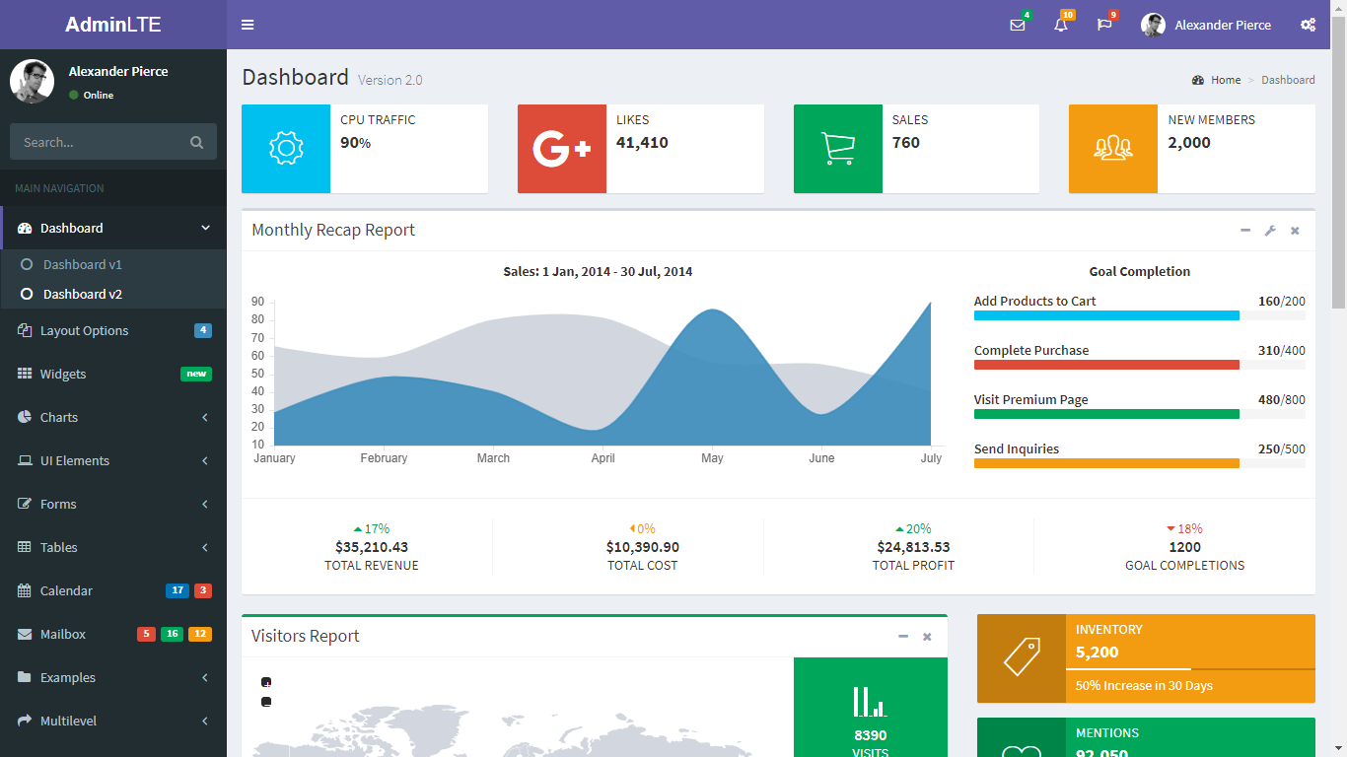

* **Manage Users/Patients**:- Admin can add/edit/delete users, patients from its panel. They can disable/enable any user from this section
  + List users
  + Search users by name, email, phone
  + Add/Edit users
  + Delete Users
  + Disable/Enable users
  + Search users:- A search form will be provided with some filters like name, user type, phone number, city, email etc. The search result will be displayed in a tabular format with the details.

Patients’ data will be stored into our database with 2-way encryption format with a specific defined private keys(end-to-end encryption).

A sample listing page is attached below that will be displayed in the content area of the application:

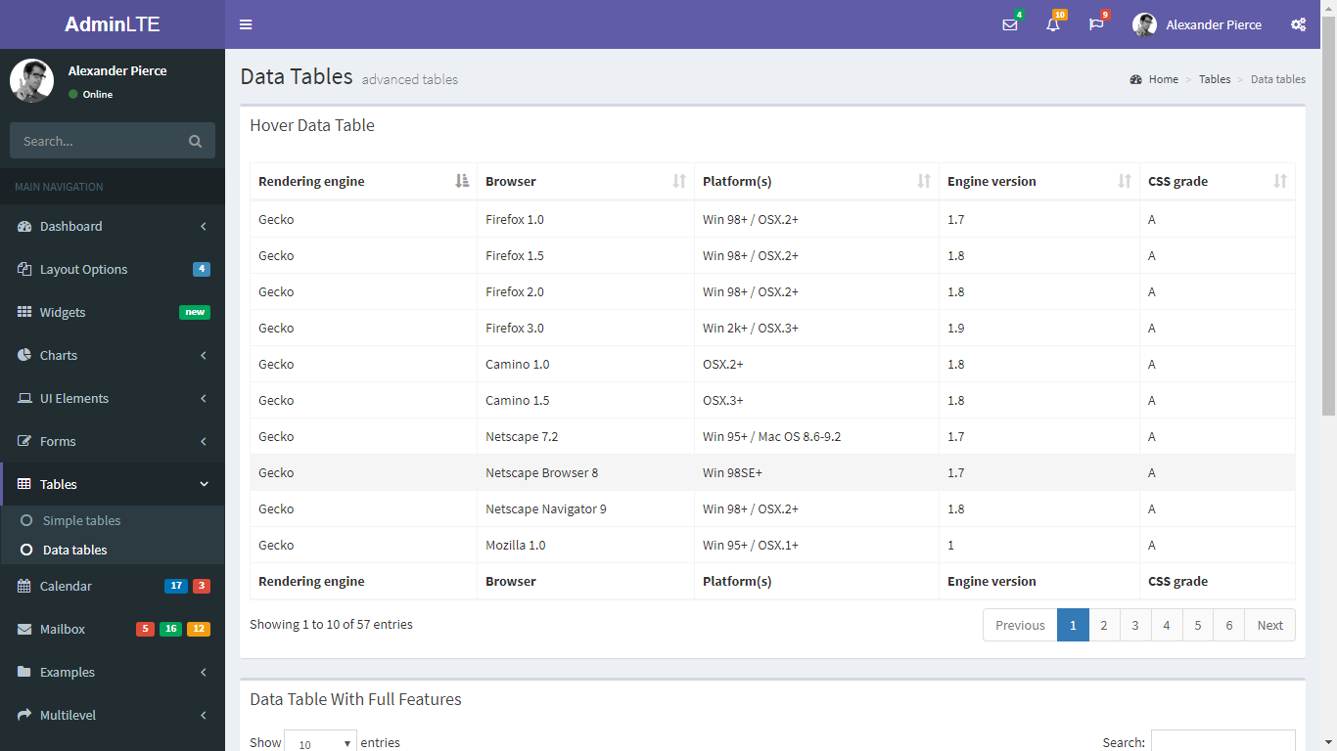

* **Manage Appointments**:-
  + Doctors can add their availability and manage their appointment slots.
  + Doctors can cancel their availability for some date.
  + A calendar view will be shown to doctors about their availability.
  + They can view the upcoming appointments.
  + They can see the view of the appointment invoices.
  + The designated user can book appointments as per doctors’ availability.
  + Appointments reminders are sent to patients via email.
  + All patient requested appointments are shown which can be approved by doctors or respective persons.
* **Billing Module:**
  + Doctors can view their open invoices.
  + They can pay their open invoices.
  + DayView will be available for all their transactions.
  + Reports:-
    - Invoices
    - Patient History/Number of patients seen
* Doctors can send Messages/Emails through website directly to imaging center.
* **Case Management:**
  + Doctors or any designated user can create case for patients
  + They can add the services added in the case
  + The charges/fee for services will be added automatically in the invoice generated. An invoice will be opened automatically when a case is registered successfully. It can be paid by the patient or it can be paid by the visiting doctor itself.
  + Documents can be added in the created cases which can be downloaded/viewed by the respective doctors.
  + A case will be assigned to one doctor at a time and based on the services offered by the doctor, a respective amount will be added in the invoice.
  + They can Download/Print cases
  + They can send the cases details/documents to other providers via email.
* **Edit Account:-** 
  + Users can edit their primary email account. A verification email will be sent in this case.
  + Users can change password from the Edit profile section.

# Patient Portal:

* Patients will get their login details when they are registered via doctors’ / backoffice panel. They can login to the patient portal using those details.
* Patients can request for an appointment with a specific doctor as per the doctor’s availability. The requested appointment will be confirmed by the respective users’ from application.
* They can send message/email to clinic via their panel.
* They can do check-in via website by submitting the required form data when there is any appointment or he/she visits the clinic.
* They can pay for the appointment invoice or any other pending invoice via website application.
* They can request the reports to the clinic and they can download the same to view.
* History of the patients’ appointments will be visible by them.
* **Edit Account:-** 
  + Users can edit their primary email account. A verification email will be sent in this case.
  + Users can change password from the Edit profile section.
  + They can update their demographic details too.

# Backend Admin:

* Login based on email address, with Recover password function.
* Login module
  + Admin login using email and password
* Dashboard page:- This will be a page where admins will be redirected after successful login. This page will give admin an overview of all the applicable reporting, quick views etc. This will include:
* Overview of all users registered, searchable by date, status, shifts etc.
* Additionally, some reporting stuff will be shown to give a quick overview of the happenings throughout the website.
* Below is a sample page of dashboard page which we will be providing with:
* Manage Locations:- Admin can add/edit/delete clinic locations from backend admin with all relevant details. They can disable/enable any user from this section
  + List Locations
  + Sort Locations by location name, added date
  + Add/Edit Locations
  + Delete Locations
  + Disable/Enable Locations
  + Search Locations:- A search form will be provided with some filters like name etc. The search result will be displayed in a tabular format with the details.
* Manage Users:- Admin can add/edit/delete users from backend admin with all relevant details. They can disable/enable any user from this section
  + List users
  + Sort users by name, email, added date
  + Add/Edit users
  + Delete Users
  + Disable/Enable users
  + Search users:- A search form will be provided with some filters like name, user type, phone number, city, email etc. The search result will be displayed in a tabular format with the details.
* Reports: There will be extensive reporting for all the stuff happening throughout the application. Below are the reports that need to be built:
  + Users Reporting: This will highlight the users registrations data in a graphical way or tabular way.
  + Total sales/revenue data from application
  + Pending payments report
  + All open/paid invoices based on doctors
  + DayView report will be there to view the transactions of the day.
  + Clinic location wise reports will be there.
  + Total Patients onboarded/served
  + Etc.
* Manage Pages content:
  + Admin can add/edit the content of the static pages from backend admin.
  + The dynamic content will be shown in the front-end website.
  + Meta information will also be managed for all the pages managed from backend admin.
* Manage Emails content:
  + Admin can edit the content of the emails that are triggered in the systems.
  + The dynamic email content will be shown while email will be sent to respective recipients.
  + There is a functionality to delete my account directly from the emails. There will be a link in the email that will take users to an URL from where the account is removed automatically.
* **Other Business Logic to be implemented:**
  + Admin can change the password.
  + Other configurations can be done by the administrator.
  + Emails will be triggered to respective users on each event performed by any user.
* QA Testing
* Testing fixes

Further discussion can be made over chat or voice call or meetings on this initial proposal and can be extended/amended as required.

4.0 Resources, Technologies Proposed, Timeframe, Pricing etc.

## 4.1 Technologies Proposed

Front-end:- HTML 5/CSS 3, React.js

Backend:- PHP, YII2/Laravel 5

Database:- Mysql/Mongodb

Server Hosting:- Any VPS or cloud (AWS, Google Cloud, Digital Ocean etc.)

## 4.2 Resources & Timeframe

# It would take around 950 man-hours for web application development. This may take around 8 weeks of development period after the project pre-sales finalization process. However, this may vary a bit based on real time complexities and the feedbacks provided during the development period.

## 4.4 Deliverables

# Once the project is completed and all milestones are paid/released, we will move the application to the client's server and deliver all the source code of the application along with all IPR (Intellectual Property Rights).

## 4.5 Warranty/Bug Fixing

# After the project delivery and final sign-off, we provide a 30 days warranty/bug fixing period wherein this case, we would fix the issues reported.

# 4.6 Assumptions

* We will work locally on our machines/staging servers and will deliver all the finalized items to the server on the basis of our milestones once accepted by the client.
* There is no other deliverable apart from the above listed points. Any other items in addition to the listed above will be treated as Change Request and separate quotation will be provided for the same.

# 4.6 Services not included

Following services are not included in the proposal and will incur additional charges:

* Hosting server charges
* Any paid third party API fee like Twilio, clickatell etc.
* Any promotional activities of the application.

## 4.7 Mitiz’s Other Collective Terms and conditions

* The terms and conditions given below are applied to all the services offered by Mitiz to its clients. Please read these terms and conditions carefully.
* The user agreement is a contract between the client and Mitiz Technologies Pvt Ltd. You must read, agree to, and accept all of the terms and conditions contained in the Agreement in order to use our services.
* The client will be involved with assigned resources via Mitiz communication channels(email, skype) only.
* Client cannot contact the developers directly (or vice-versa) via some other medium like personal email, social media profiles etc.
* In case if the client is willing to pay the bonus/perks apart from the resources’ expenses, he can pay to Mitiz and it will be passed on to the resource after deducting Govt. Applicable Taxes.
* We strictly do not sell/rent/disclose/trade the confidential data of our clients to any third-parties for whatsoever reason. Clients cannot disclose any credentials/details of Mitiz, which is meant solely for the client, to any of its competitors, third party providers or whosoever.

5.0 Maintenance and Support Services

# Once the application is developed fully and is ready to go live, we provide maintenance/support with following options:

* Full time resource allocation for Web Application:- This plan will include the allocation of the desired resources on man-month basis. The assigned team will be assigned dedicatedly on the project and will perform the desired operations as discussed and required by the project stakeholders. The assigned resource will not work on other clients' projects.
* Ad-hoc or Hourly basis resources allocation:- This plan will include the allocation of the desired resources on hourly basis. The assigned team will be assigned on ad-hoc basis. They will perform the desired operations as discussed and required by the project stake holders. The assigned resource may work on other clients' projects.

By opting-in first option (Full time resource allocation) listed above, we will cover daily backups, any hacking attempts and take care of all the required actions needed in order to run the site and application seamlessly.

